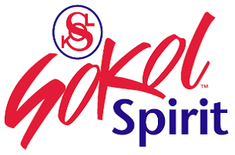
Czech Language Programs- Winter 2024
REGISTRATION & PAYMENT FORM

PLEASE CHECK ALL THAT APPLY

Option 1: Conversational Czech for Life Learners
Monday Mornings from 10:00 to 11:30 AM
In-Person classes- in lower level hall (some stairs) Minimum enrollment of 3 students

• Session III – 4 weeks, February 5, 12, 19, & 26, 2024 - $64 $_________
• Session IV – 4 weeks, March 4, 11, 18, & 25, 2024 - $64 $_________

Option 2: Individual Czech language lessons via Zoom/In-person
Schedule as agreed between Student and teacher @ $30 per lesson, payable monthly
Month ______________________ # of lessons _____ x rate $30 TOTAL $_________

Option 3: Virtual Czech language Social Club
Meets 1 Wednesday per month, at 7:00 PM via Zoom (login upon registration)
Basic Czech conversations with life learners on familiar topics and more
Dates: January 31, February 28, & March 27 - all 3 sessions total $30 $__________

Registrant Please print Today’s Date______________, 2024

(Last & First Name) ______________________________________________________
Address _____________________________________________________________________
City _______________________________________, State ______ Zip__________
Home phone ____/___________ Cell phone ____/__________ are you on Facebook? Y / N
Preferred phone to leave a message ________________________ Text OK? Y / N
E-mail _________________________________________________________
How did you hear about these classes/sessions?_______________________

Form of Payment for class/session:

_____ Check #__________, Bank ______________________;
_____ Cash $ ___________
_____ Credit/Debit - https://www.sokolspirit.org/education/czech-classes/ - blue pay online button
Please complete and submit this form, no matter what form of payment you use.

Coming soon: Periodic Cultural and Historical Programs

SOKOL SPIRIT, 3909 South Prairie Avenue, Brookfield, IL 60513
Sokol Spirit is a not-for-profit 501(c)3 organization - incorporated in Illinois

